**Recruiting**

**in Oracle**

Table of Contents

Entering a Job Requisition 3

Posting the Job Requisition 9

Viewing Your Applications 13

Initiating an Offer 14

# Entering a Job Requisition

From the Home screen of Oracle, go to **My Team** – **Hiring**.

Now click **Job Requisitions**.

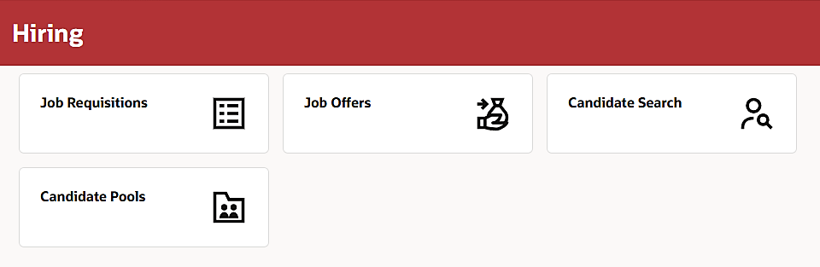

Click **Create**.

In the **How to Start** section, select **Standard** for the **Requisition Type** (a below). In the **Create Requisition Using** field (b below), select **Position**. Then select your **Business Unit** (c below).

**c**

**b**

**a**

Next click the **Position** field (see star below). Start typing the name of the position into the field, then select it from the choices. Then hit **Continue**.

In the **Basic info** section, just click **Continue** (circled below).

In the next section, click into the **Hiring Manager** field and begin typing the first or last name of whomever will make the decision on the hire (if that’s you, type in your name), then select the correct name from the list.

After selecting the hiring manager, *if anyone else needs to be in the loop on this hire,* you can hit **Add** (see arrow below) to add another collaborator (and type their name into the new field added to select them). Then click **Continue** (circled below).

For the **Recruiting Type** (a below), if the job is in CSCD or the Sheriff’s Office, select that from the drop-down. Everyone else should leave this on **General**. In the **Organization** field (b below), begin typing the name of your department, then select the **Administration** listing of your office. You can leave the Job Family and Job Function as is. If a change is needed there, HR will do that. Hit **Continue** at the bottom.

**b**

**a**

In the **Offer Info** section, all required fields should be filled in based on everything you have already entered. Hit **Continue**.

You don’t need to add an attachment, just hit **Continue**.

Under **Configuration**, set the **Candidate Selection Process** (a below) to **General** (*unless* you’re entering a job requisition for the Sheriff’s Office). **External Application Flow** (b below) should default correctly. Set both **Allow Candidates to Apply When Not Posted** (c below) and **Automatically Fill Position** (d below) to **No**. Click **Continue**.

In the **Prescreening questions** section, you will see several basic questions already populated. If you want to add another question, you can hit the **Add** button (see arrow below), then select the question from a drop-box that appears. Otherwise, hit **Submit**.

Now the job requisition goes to HR for approval.

# Posting the Job Requisition

When HR approves the job requisition, you should get an email notification (and a notification on your Home screen of Oracle). When you receive that notification, go to **My Team** – **Hiring**.

Click **Job Requisitions**.

Click the Job Requisition you need to post.

Click **Move to Posting** near the top right.

Now click the **pencil** by **Internal career site**.

In the **Posting Schedule** field (see star below), you can choose **Post Now** (which, after saving, will post the job within 15 minutes) or **Post Later** (which will allow you to select a date and time to post the job).

If you choose **Post Later**, you need to specify the **Date** and **Time** you want this job to post. In the **Start Date** field, you can either type in the date you want this job to post or click the calendar button (see arrow below) to open a **Date/Time** picker to select the date, time, and hit **Done** (highlighted below) on the calendar. You can also set an **End Date** for posting (see star below). Click **Save** when you’re done (circled).

You can click this time to select an exact time for posting

Now click the pencil by the **External career sites**.

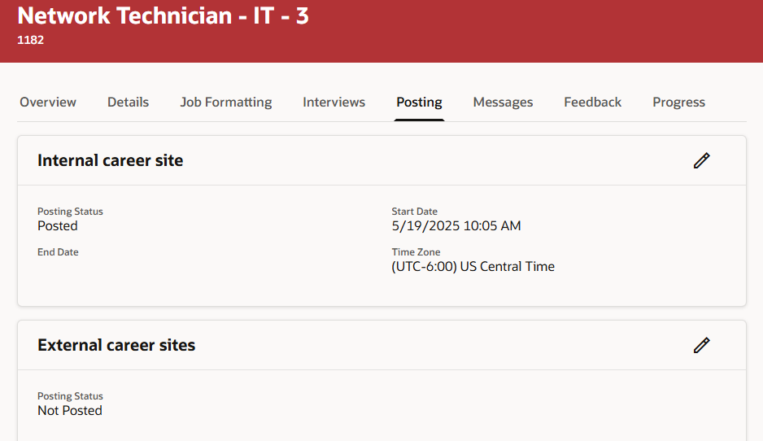

In the **Posting Schedule** field (see star below), you can choose **Post Now** (which, after saving, will post the job within 15 minutes) or **Post Later** (which will allow you to select a date and time to post the job).

If you choose **Post Later**, you need to specify the **Date** and **Time** you want this job to post. In the **Start Date** field, you can either type in the date you want this job to post or click the calendar button (see arrow below) to open a **Date/Time** picker to select the date, time, and hit **Done** (highlighted below) on the calendar. You can also set an **End Date** for posting (see star below). Click **Save** when you’re done (circled).

You can click this time to select an exact time for posting

# Viewing Your Applications

You should receive email notifications when you start receiving applications for the job. To review the applications, go back into **My Team** – **Hiring**.

Then you will see the most recent job requisitions you are involved with. To view the applications, click the number under either **New Applications** (to see the most recent applications) or **Applications** (circled below).

After clicking into the applications, click the name of the candidate you want to review (see arrows below).

Next you see a screen with their key info and resume first. You can click on any of the tabs across the top (circled in blue below) to view additional information the candidate provided. When you’re done reviewing, click the back arrow near the top left (circled in yellow below) to go back to the list of candidates.

# Initiating an Offer

When you have decided on the right candidate, you need to initiate a job offer to them. To start that, go back into **My Team** – **Hiring**.

Click the number under **Applications** (circled below).

Look for the candidate you’d like to hire and click their name.

Now click the ••• in the left pane (see arrow below) and select **Move Application** (circled).

When the next screen loads, set the **Phase** to **Offer**, set the **State** to **To be Created**. Then in the **Comment** box, enter the following :

* Starting Rate of Pay
* Estimate Hire Date
* New Hire / Rehire
* Drug Screen: Yes / No
* Background Scree: Yes/ No
* R&B only : CDL vs. Non-CDL

Then hit the **Move** button at the bottom right (circled below).

Since this is a job in IT, I didn’t enter the R&B (Road and Bridge) part (CDL vs Non-CDL)

Human Resources takes over on the hire from this point. Human Resources will use this information to draft and extend the Job Offer.

Your portion of the recruiting is done!